1. Write the below program with the parameterized constructor.
   1. Average of three integer numbers, three float numbers(should have same method name)
   2. Area of figures(circle, rectangle, square) by using three methods(should have same method name)

import java.util.Scanner;

public class AverageConst

{

int a,b,c;

float d,e,f;

AverageConst()

{

Scanner sc = new Scanner(System.in);

System.out.println("Integer Average");

System.out.print("Enter the first integer number: ");

a = sc.nextInt();

System.out.print("Enter the second integer number: ");

b = sc.nextInt();

System.out.print("Enter the third integer number: ");

c = sc.nextInt();

System.out.println("float Average");

System.out.print("Enter the first float number: ");

d = sc.nextInt();

System.out.print("Enter the second float number: ");

e = sc.nextInt();

System.out.print("Enter the third float number: ");

f = sc.nextInt();

}

public static void main(String[] args)

{

AverageConst ob = new AverageConst();

int avg = (ob.a + ob.b + ob.c)/3;

float avg2 = (ob.d + ob.e + ob.f)/3;

System.out.println("The average of entered integer numbers are:" +avg);

System.out.println("The average of entered float numbers are:" +avg2);

}

}

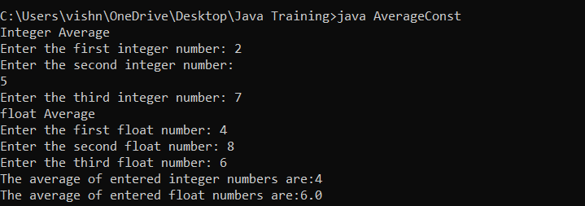

import java.util.Scanner;

public class Areaconst

{

double a;

int b,c,d;

Areaconst()

{

Scanner sc = new Scanner(System.in);

System.out.println("Area of circle");

System.out.println("Enter the radius of the circle: ");

a = sc.nextInt();

System.out.println("Area of rectangle");

System.out.println("Enter the length");

b = sc.nextInt();

System.out.println("Enter the breadth");

c = sc.nextInt();

System.out.println("Area of square");

System.out.println("Enter the one side length");

d= sc.nextInt();

}

public static void main(String[] args)

{

Areaconst ob=new Areaconst();

double a1=3.14\*(ob.a\*ob.a);

int a2= ob.b\*ob.c;

int a3= ob.d\*ob.d;

System.out.println("The area of circle is:" +a1);

System.out.println("The area of rectangle is:" +a2);

System.out.println("The area of square is:" +a3);

}

}

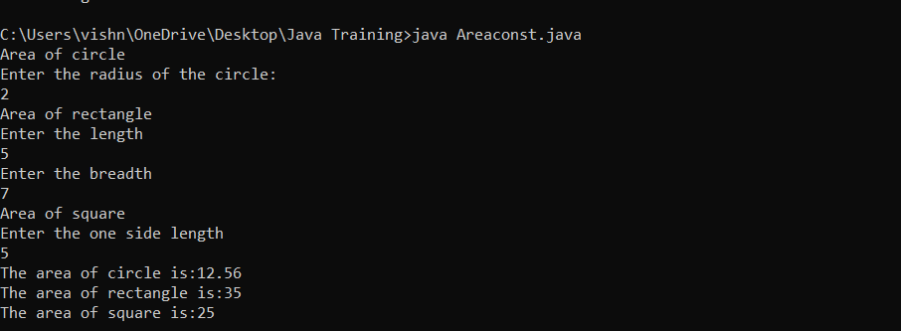

1. Write a program to find the grade of 2 students based on total marks(3 subjects)
   1. Get the student’s marks by constructor
   2. Return total mark to in main method
   3. Find the grade of each student.

import java.util.Scanner;

public class Studentgrade

{

int a,b,c,d,e,f;

Studentgrade()

{

Scanner sc = new Scanner(System.in);

System.out.println("Student 1");

System.out.print("Enter the marks obtained in English: ");

a = sc.nextInt();

System.out.print("Enter the marks obtained in Maths: ");

b = sc.nextInt();

System.out.print("Enter the marks obtained in Science: ");

c = sc.nextInt();

System.out.println("Student 2");

System.out.print("Enter the marks obtained in English: ");

d = sc.nextInt();

System.out.print("Enter the marks obtained in Maths: ");

e = sc.nextInt();

System.out.print("Enter the marks obtained in Science: ");

f = sc.nextInt();

}

public static void main(String[] args)

{

Studentgrade ob = new Studentgrade();

int total1 = ob.a+ob.b+ob.c;

int total2= ob.d+ob.e+ob.f;

System.out.println("The total marks of Student 1 is:" +total1);

System.out.println("The total marks of Student 2 is:" +total2);

if(total1>=281 && total1<=300)

{

System.out.println("Student1 grade is A");

}

else

if (total1>=271 && total1<=280)

{

System.out.println("Student1 grade is B");

}

else

if (total1>=261 && total1<=270)

{

System.out.println("Student1 grade is C");

}

else

if (total1>=240 && total1<=260)

{

System.out.println("Student1 grade is D");

}

else

if (total1<240)

{

System.out.println("Student1 is Failed");

}

if(total2>=281 && total2<=300)

{

System.out.println("Student2 grade is A");

}

else

if (total2>=271 && total2<=280)

{

System.out.println("Student2 grade is B");

}

else

if (total2>=261 && total2<=270)

{

System.out.println("Student2 grade is C");

}

else

if (total2>=240 && total2<=260)

{

System.out.println("Student2 grade is D");

}

else

if (total2<240)

{

System.out.println("Student2 is Failed");

}

}

}

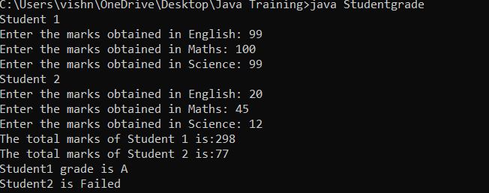

1. Program to find the reverse of a number
   1. Two constructors, one for calculation reverse and the other for display “Finding reverse…”
   2. Argument variable and instance variable should be the same
   3. The main method allows invoking only one constructor

import java.util.Scanner;

public class ReverseConst

{

int a,r;

int rev=0;

ReverseConst()

{

Scanner sc = new Scanner(System.in);

System.out.println("Enter the number");

a = sc.nextInt();

while(a>0)

{

r=a%10;

rev=rev\*10+r;

a=a/10;

}

ReverseConst ob = new ReverseConst(rev);

}

ReverseConst(int rev)

{

System.out.println("Reverse: " +rev);

}

public static void main(String[] args)

{

ReverseConst ob = new ReverseConst();

}

}

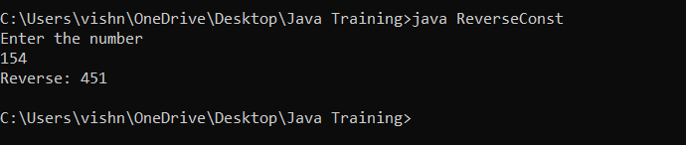

1. Program to find the factorial of a number
   1. Two constructors, one for find calculate and the other for the print result.
   2. Pass the number as argument
   3. The main method allows to invoke only one constructor

import java.util.Scanner;

public class Factorialconst

{

int a;

int fact=1;

Factorialconst()

{

Scanner sc = new Scanner(System.in);

System.out.println("Enter the number");

a = sc.nextInt();

for(int i=1;i<=a;i++)

{

fact=fact\*i;

}

Factorialconst ob = new Factorialconst(fact);

}

Factorialconst(int fact)

{

System.out.println("Factorial: " +fact);

}

public static void main(String[] args)

{

Factorialconst ob = new Factorialconst();

}

}

